Lab Assignment 6
Stepan Shkrobak
Dr. Michael Bartolacci
IST 894, Section 001: Capstone Experience,
3 March 2026

Table of Contents
Table of Contents 1
General Context 2
Technical Context 3
Screenshots 4
References 13

General Context
The first lab, MITRE ATT&CK - Credential Access - Brute Force, focused on brute force attacks and how attackers attempt to break into systems by repeatedly trying different username and password combinations. From a general security perspective, this lab demonstrates how automated tools can quickly test thousands or even millions of possible login credentials against services such as remote server access, file transfer services, and website login pages. The key issue is that weak passwords and poorly protected login systems can allow attackers to eventually guess the correct credentials. For organizations, this highlights the importance of implementing strong password policies, limiting repeated login attempts, and using additional security protections such as multifactor authentication. As cybersecurity guidance explains, “a brute-force attack consists of an attacker submitting many passwords or passphrases with the hope of eventually guessing correctly” (Kaspersky, 2023). Understanding how these attacks work helps organizations recognize why stronger authentication controls and monitoring systems are essential to protect business systems and data, as well as for users to understand how to create passwords that work against these attacks.
The second lab, MITRE ATT&CK - Credential Access - Credential Dumping, focused on the security risks associated with improperly stored credentials on a computer system. Many systems contain sensitive information such as passwords, private keys, and authentication data stored in files or system memory. If these credentials are left unprotected or stored in plain text, attackers who gain access to a machine may be able to easily retrieve them. This lab shows the broader cybersecurity issue of unsecured credential storage and how attackers may search through command history, configuration files, or system databases to recover sensitive login information. In real-world environments, this type of vulnerability often occurs due to poor security practices, such as saving passwords in scripts or configuration files without encryption. According to the MITRE ATT&CK framework, attackers frequently search for unsecured credentials because they “may be stored in files, configuration data, or other locations that allow adversaries to obtain account information” (MITRE, 2023).
The third lab, MITRE ATT&CK - Credential Access - Credentials from Password Stores, focused on how attackers can get credentials from web browsers, password managers, and network configuration files. Modern systems often store passwords to make logging into websites and networks easier for users. While this improves convenience, it also creates potential risks if a computer becomes compromised. If attackers gain access to a device, they may be able to extract stored passwords and reuse them to access additional systems or accounts. This lab shows the broader security issue of protecting password storage locations and ensuring that sensitive credentials cannot easily be extracted from applications or operating systems.

Technical Context
The first lab, MITRE ATT&CK - Credential Access - Brute Force, covered brute force authentication attacks against several common network services, showing how attackers can automate credential guessing against exposed systems. According to the National Institute of Standards and Technology, brute force password attacks remain a common threat when authentication systems rely solely on passwords without additional protective controls (NIST, 2025). Tools such as Hydra, Patator, Medusa, and Nmap were used to simulate dictionary-based brute force attacks against SSH services using credential lists. Hydra, for example, was used with commands such as hydra -L ssh-users.txt -P /usr/share/wordlists/rockyou.txt bluetech.com -t 16 ssh, which attempts authentication against an SSH service using multiple usernames and passwords in parallel threads. Similar attacks were performed with Patator using python3 patator/patator.py ssh_login host=bluetech-backup.com user=FILE0 password=FILE1, and with Medusa using medusa -h bluetech-demo.com -U ssh-users.txt -P /usr/share/wordlists/rockyou.txt -M ssh. Nmap was also used through nmap --script ssh-brute -p22 to show how automated scanning tools can integrate brute force authentication testing during reconnaissance.
The second lab, MITRE ATT&CK - Credential Access - Credential Dumping, focused on finding and dumping credentials on Linux systems where authentication data is improperly stored or accessible. For example, unsecured credentials stored in files were found using recursive searches such as grep -i -E 'password' -r /home/ubuntu-user/Documents, while SSH key discovery was performed using sudo find / -name "*.pub" -exec grep "ssh-rsa" {} \;. In the lab, we also saw how attackers can extract credential hashes from /etc/passwd and /etc/shadow using custom scripts such as sudo python3 shadow.py, which parsed account records to collect usernames and hashed passwords. These hashes can then be attacked offline using password cracking tools such as John the Ripper with commands like ./john --format=keepass -w=/usr/share/wordlists/rockyou.txt hashfile.txt. Even process memory could contain credentials so the lab showed how credential extraction through /proc using a memory dumping script sudo python3 memdumping.py <PID>, and thne searching the dump for credentials with commands like strings X.dump | grep Username:.
The third lab, MITRE ATT&CK - Credential Access - Credentials from Password Stores, focused on credential extraction from password stores and application storage locations. Network connectivity and system interfaces were first looked at using tools like ping and ifconfig, while system logs were examined using sudo grep "wlan" /var/log/syslog to identify wireless activity. Many people store passwords in browsers or password managers to make their lives easier, but putting themselves more at risk. As Cisco notes, credential harvesting from stored password repositories can enable attackers to reuse credentials across systems and escalate access throughout a network (Cisco, 2023). In the lab we exported Browser passwords from Firefox and Chrome into CSV files and analyzed with cat chrome-logins.csv | column -s, -t for readability. Password decryption from Firefox profiles was demonstrated using the script python3 firepwd.py -d /home/ubuntu-user/.mozilla/firefox/*.default-release. The lab also included automated credential extraction using LaZagne sudo python3 laZagne.py all -v to recover saved passwords from multiple applications. And we finished off by decrypting files using OpenSSL after discovering the correct password.

Screenshots

MITRE ATT&CK - Credential Access - Brute Force
Brute Forcing SSH With Hydra
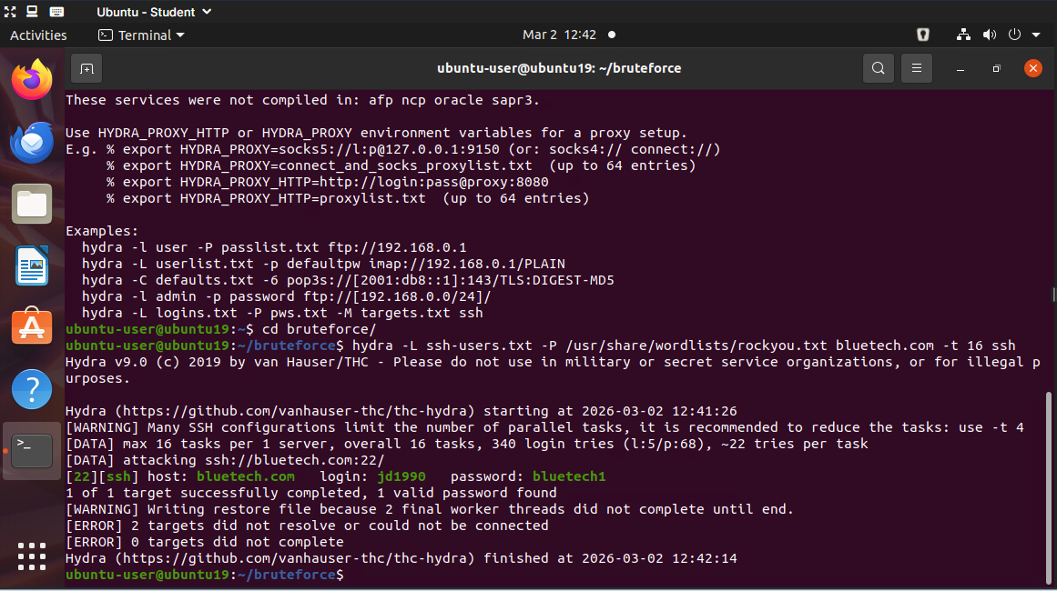

Brute Forcing SSH With Patator
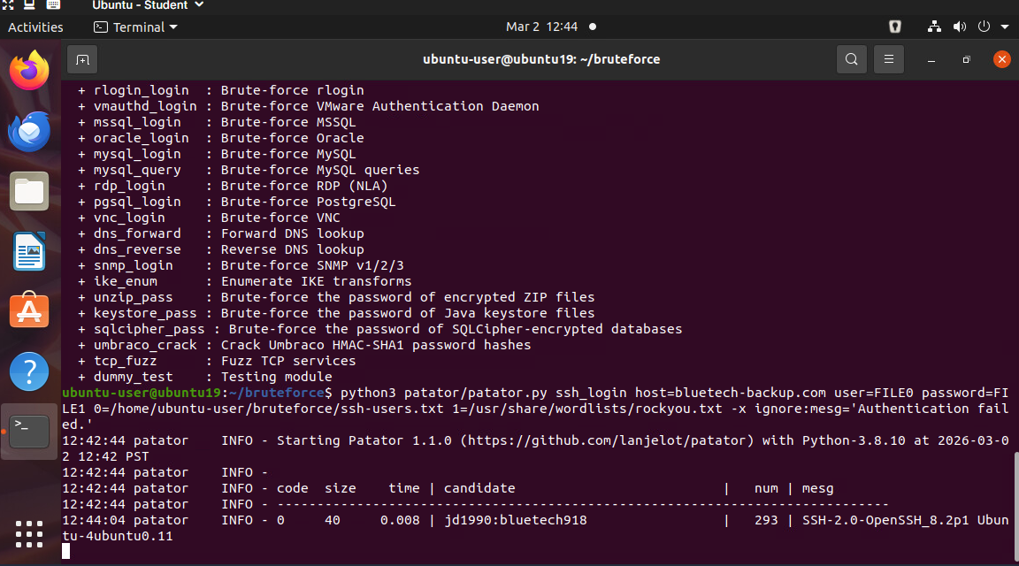

Brute Forcing SSH With Medusa
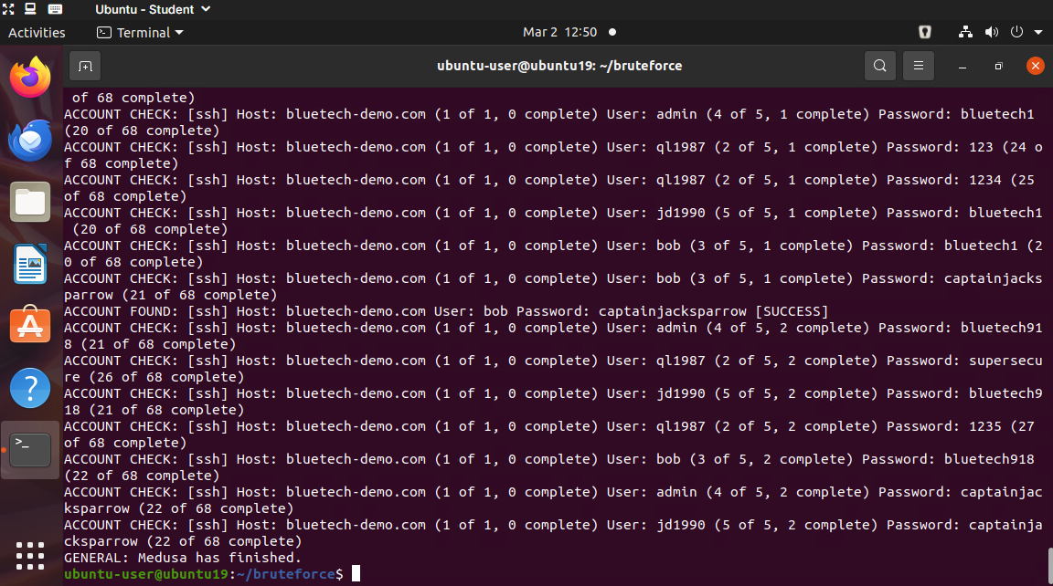

Brute Forcing SSH With Nmap
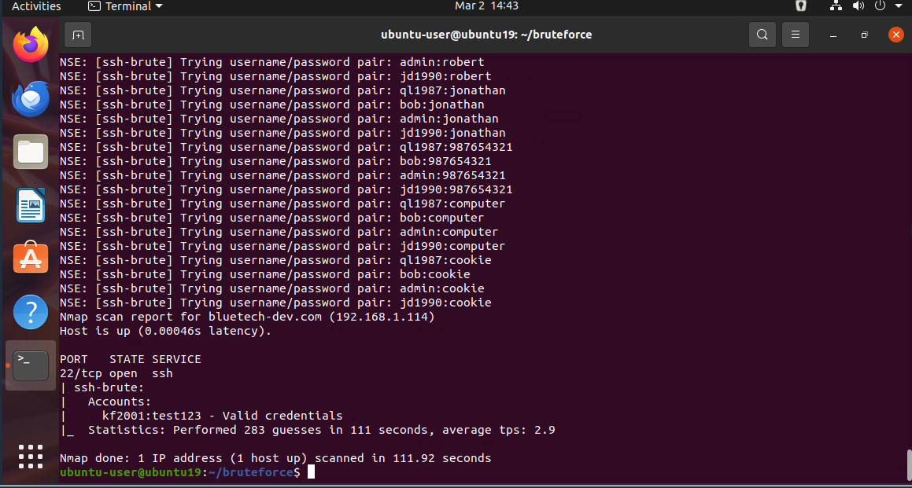

Brute Forcing FTP With NCrack
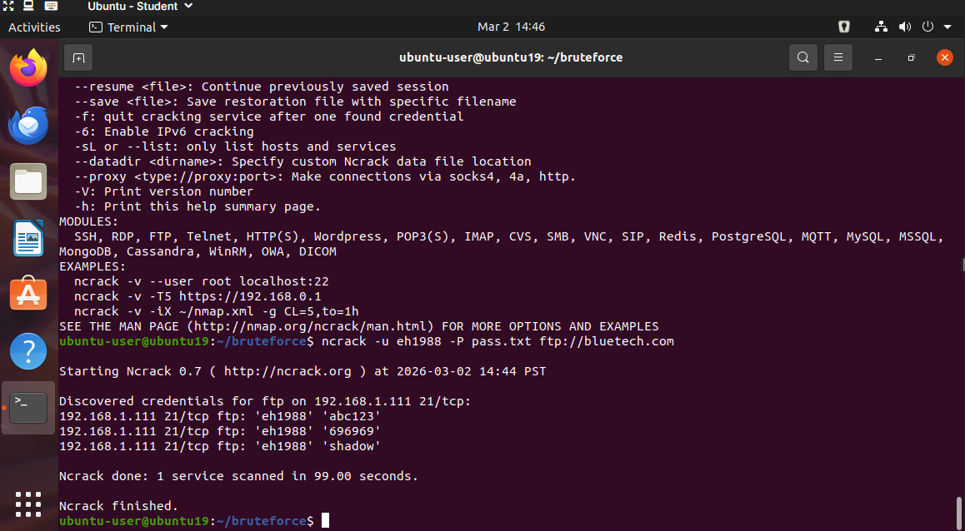

Brute Forcing Directories With Dirb

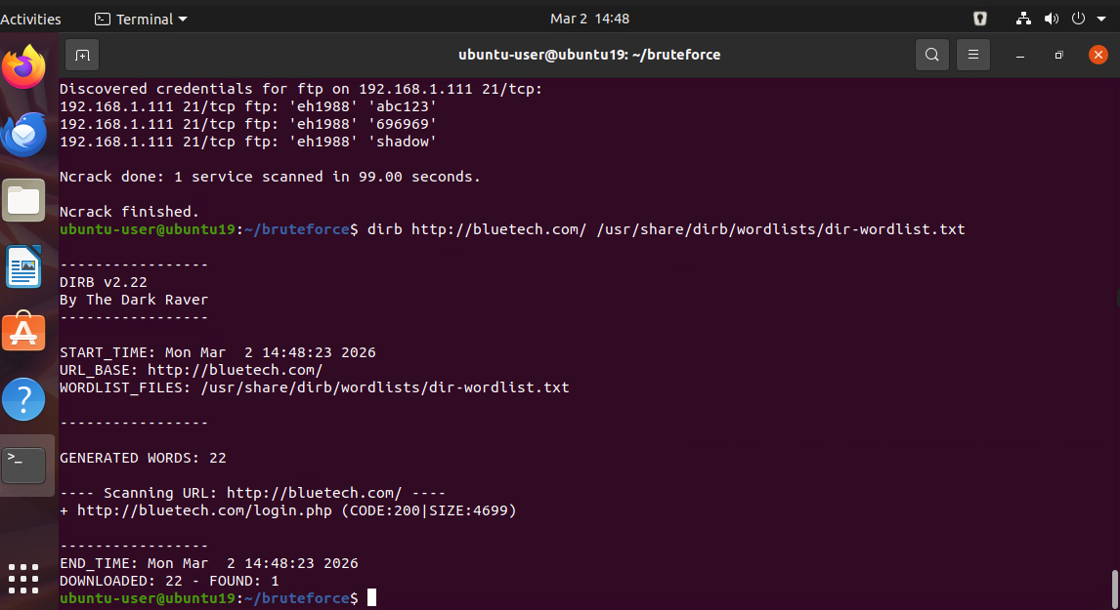

Brute Forcing Directories With Gobuster
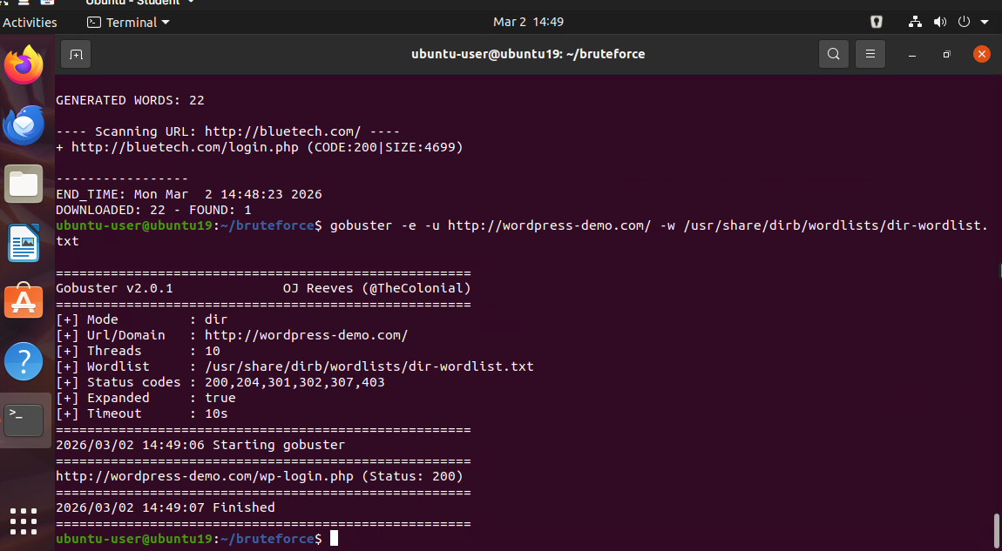

Web Login Brute Forcing
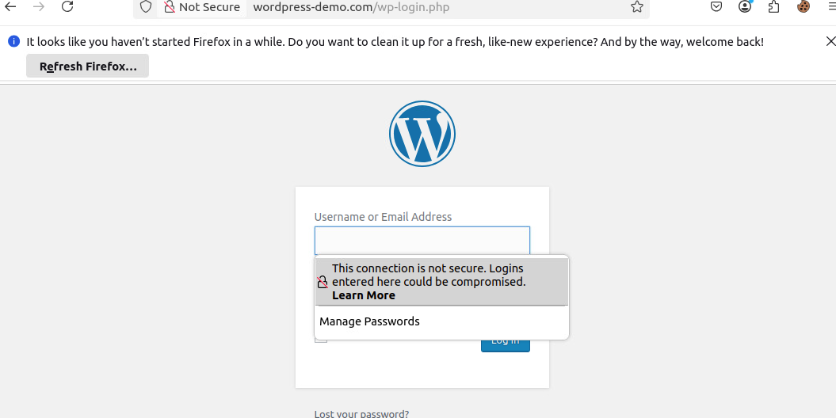

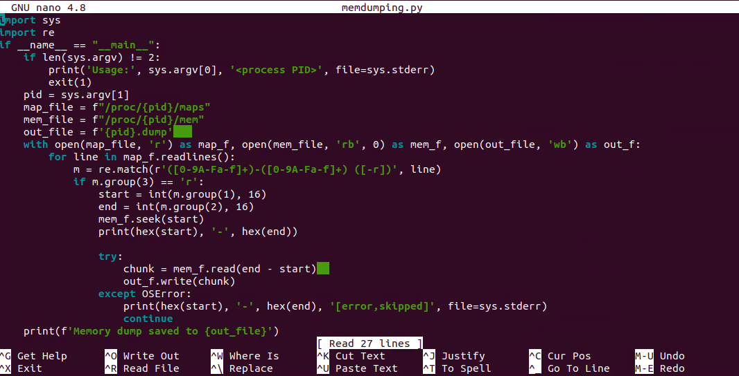

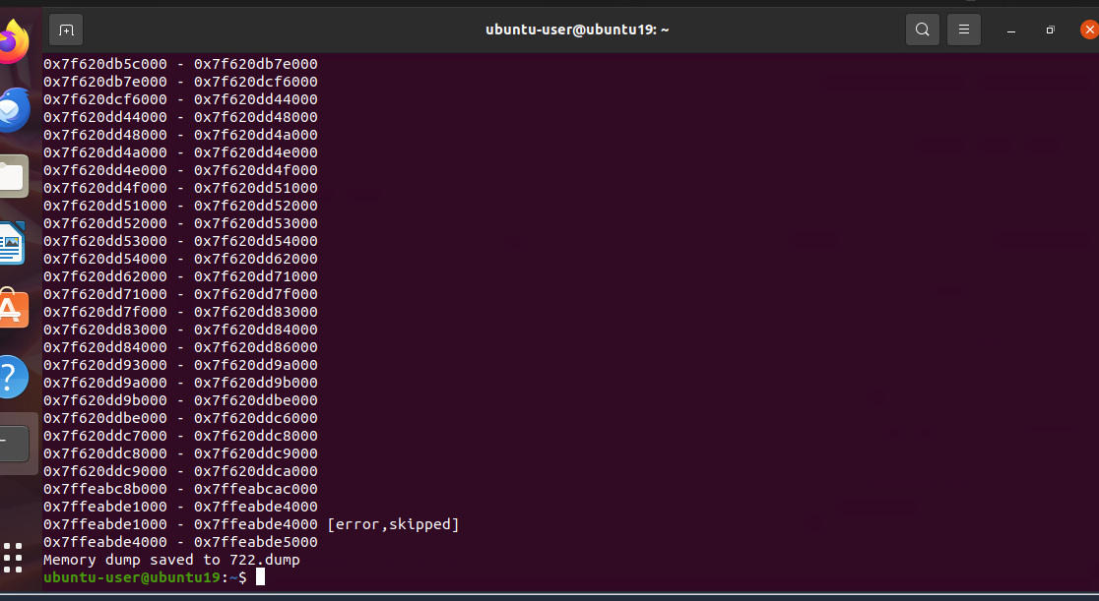
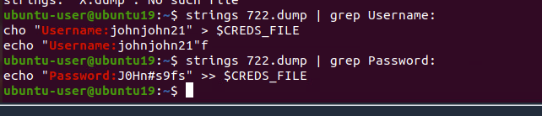
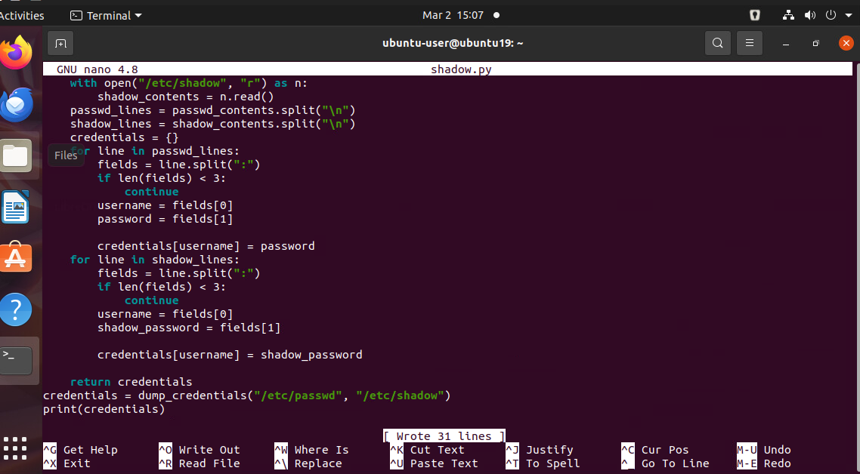
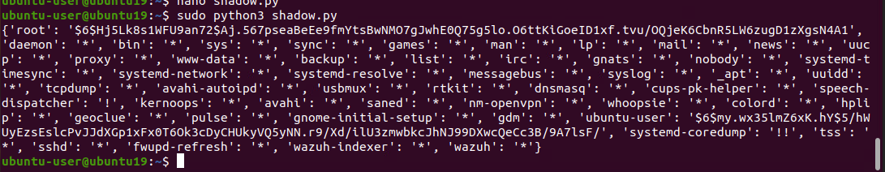
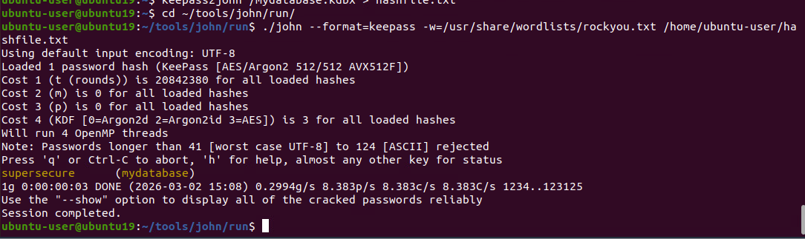
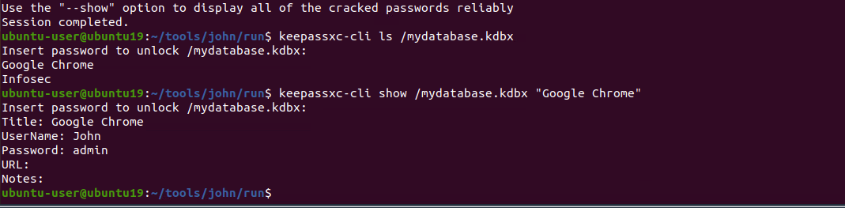
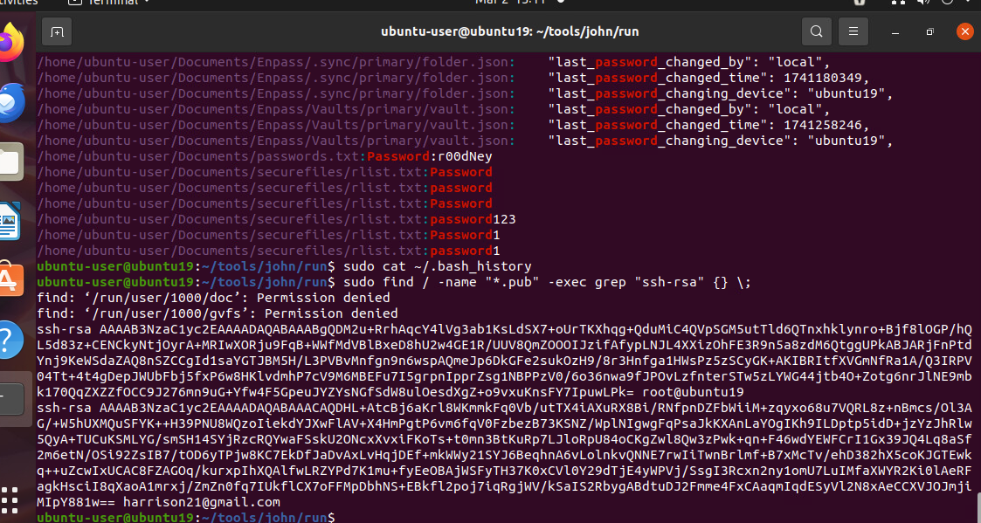

Networking Tools

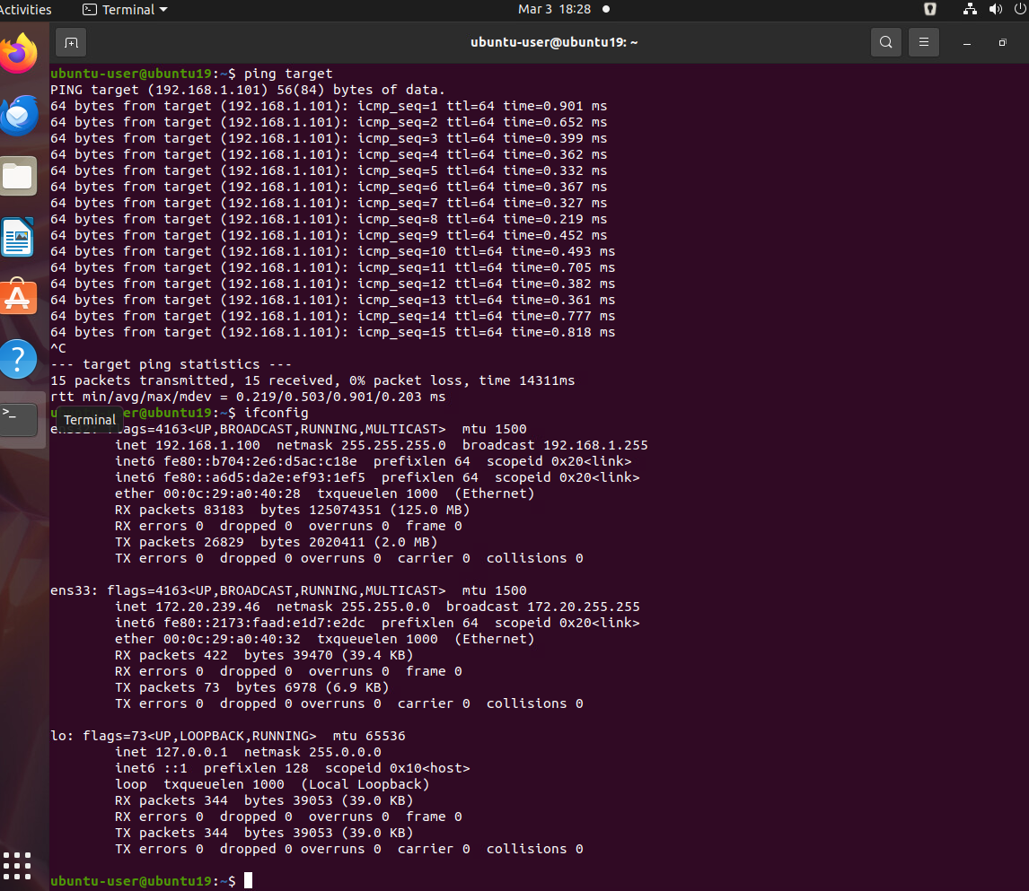
Check Interface

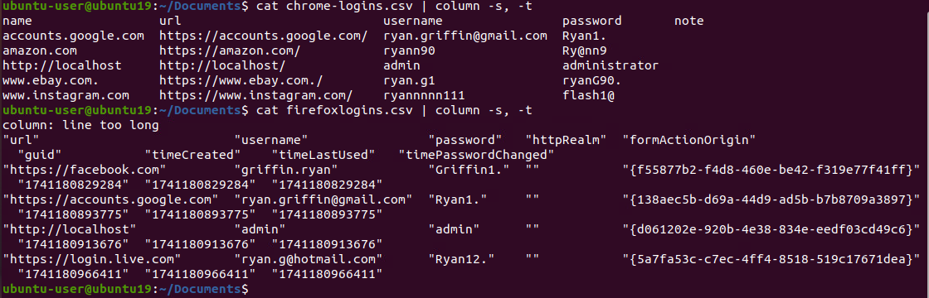
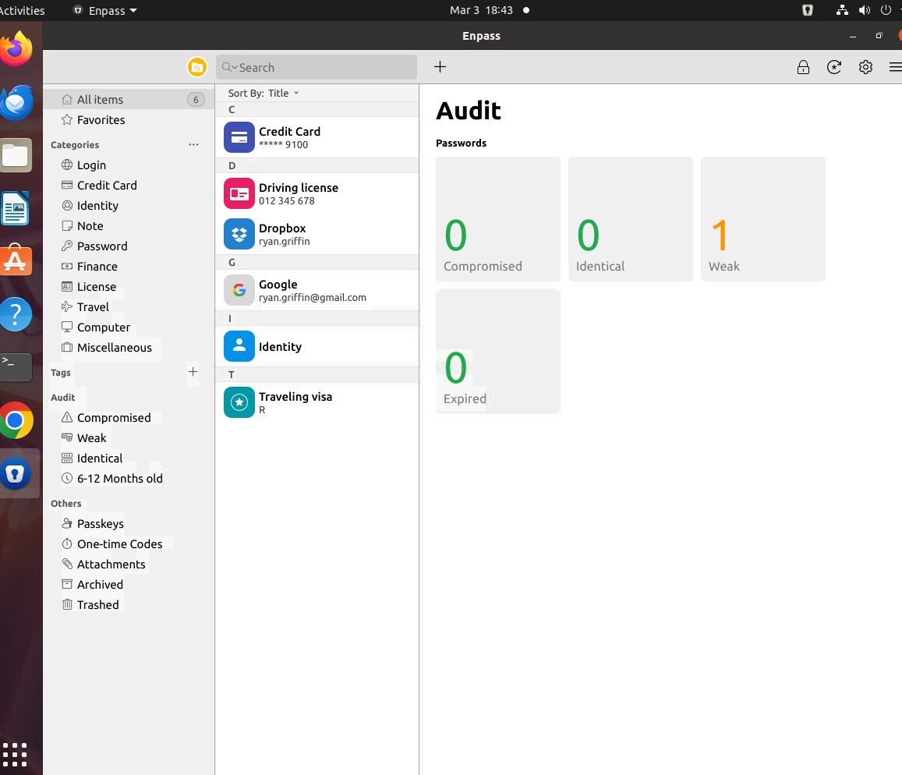
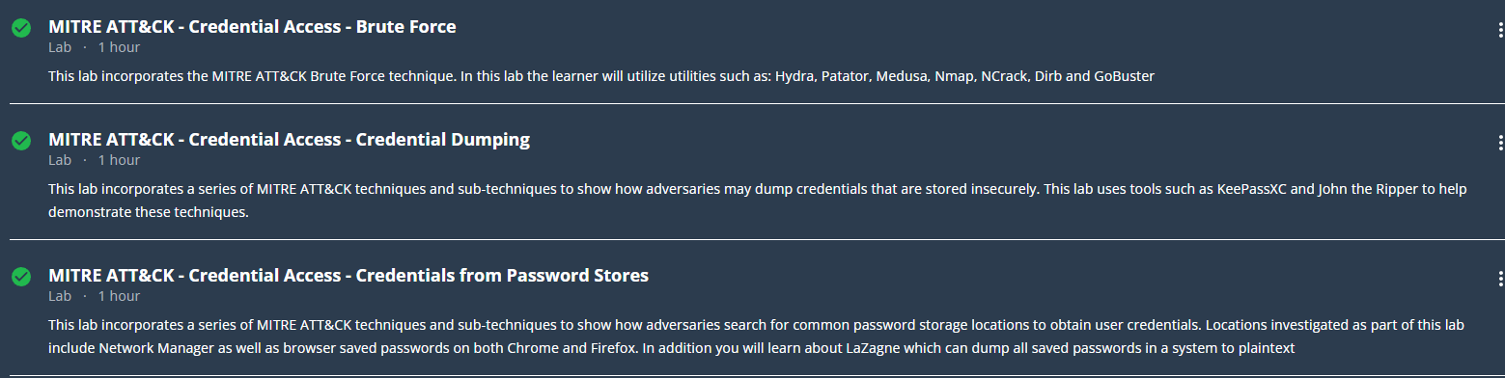

References

Cisco. (2023). Credential harvesting and password attacks in enterprise environments. https://www.cisco.com/c/en/us/products/security/index.html
Kaspersky. (2023). What is a brute force attack? https://www.kaspersky.com/resource-center/definitions/brute-force-attack
MITRE. (2023). MITRE ATT&CK: Credentials from Password Stores (T1555). https://attack.mitre.org/techniques/T1555/
National Institute of Standards and Technology (NIST). (2025). Digital identity guidelines: Authentication and authenticator management (SP 800-63B Rev. 4). https://pages.nist.gov/800-63-4/sp800-63b.html

